A Mini Project Report
On
GEO TRACKING OF WASTE
Submitted in the fulfillment of the requirement for the award of the degree of
BACHELOR OF TECHNOLOGY
In
COMPUTER SCIENCE AND ENGINEERING(AI&ML)
Under the Guidance of
Mrs. G. ADILAKSHMI
Assistant Professor
By
A. SRIVARSHA 23D21A6663
K. HARIKA 23D21A6681
K. SUPRIYA 23D21A6688

Department of Computer Science and Engineering (AI&ML)
SRIDEVI WOMEN’S ENGINEERING COLLEGE
( Approved by AICTE and affiliated to JNTUH,An UGC Autonommous Institution,
Accredited by NBA and NAAC With A++ Grade| Certified with ISO 9001:2015
Vattinagulapally, Gandipet, Hyderabad-75 , 2025-2026

Department of Computer Science and Engineering (AI&ML)
SRIDEVI WOMEN’S ENGINEERING COLLEGE
(An UGC Autonomous Institution)
(Estd. 2001 | Approved by AICTE & Govt. of TS |Affiliated to JNTUH
Accredited by NBA and NAAC(A++) |Certified with ISO 9001:2015
V.N.PALLY, Gandipet, Hyderabad-75 2025- 2026

CERTIFICATE
This is to certify that the MINI PROJECT REPORT entitled “GEO TRACKING OF WASTE” is being submitted by A.SRIVARSHA(23D21A6663), K.HARIKA (23D21A6681), K.SUPRIYA (23D21A6688) in partial fulfillment of the requirement for the award of the degree of Bachelor of Technology in Computer Science and Engineering(AI&ML) is a record of Bonafide work carried out by them.

Internal Guide Coordinators Head of the Deparment

Mrs. G. Adilakshmi Dr. Lipika Goel Dr. Lipika Goel
Asst. Professor Professor Professor
Mrs. Mounika
Asst. Professor

EXTERNAL EXAMINAR

DECLARATION
We hereby declare that Mini Project entitled “GEO TRACKING OF WASTE” is the work done during the period from 15 December 2025 to 10 April2026 and the same is submitted in partial fulfillment of the requirements for the award of degree of Bachelor Of Technology in Computer Science and Engineering (AIML) from Jawaharlal Nehru Technological University, Hyderabad.

A. Srivarsha 23D21A6663
K. Harika 23D21A6681
K. Supriya 23D21A6688

ACKNOWLEDGEMENT
We would like to express our sincere gratitude and indebtedness to our Internal guide, Mrs.G.Adilakshmi, Department of Computer Science and Engineering(AI&ML) for her valuable guidance, suggestions, and keen personal interest throughout the course of this project and for his tireless patience in hearing all our seminars, minutely seeing all the reports and giving appropriate guidance and suggestions.
We would like to express our sincere gratitude to our both the Project co-ordinators Dr.Lipika Goel, Professor and Mrs. Mounika, Assistant Professor, Department of Computer Science and Engineering(AI&ML) for there timely cooperation and valuable suggestions throughout the project. We are indebted to them for the support given to us throughout the project work.
We would like to express our sincere gratitude to Dr. LIPIKA GOEL, Professor and Head, Department of CSE(AI&ML) for her valuable suggestions and advices.
We are also extremely thankful to Dr. A. NARMADA, Principle of Sridevi Women’s Engineering College for her precious guidance and Valuable suggestions.
Finally, we would like to take this opportunity to thank all our faculty, family and friends for their support throughout this work. We also sincerely acknowledge and thank all those who gave directly or indirectly their support in completion of this work.

A. Srivarsha 23D21A6663
K. Harika 23D21A6681
K. Supriya 23D21A6688

LIST OF CONTENTS
S.no Page No
Title page
Certificate (College) ii
Declaration iii
Acknowledgements iv
List of Contents v
List of figures vii
List of tables viii
Abstract ix
1. Introduction 1
1.1 Purpose 1
1.2 Scope 1
1.3 Definitions, Abbreviations and Model Diagrams 2
1.4 Overview 5
2. Literature survey 6
3. System Analysis 7
3.1 Existing System & Disadvantages 7
3.2 Problem Statement 8
3.3 Proposed System & Advantages 8
4. System Requirements Specification 10
4.1 Functional Requirements 10
4.2 Non-Functional Requirements 10
4.3 Software Requirements 11
4.4 Hardware Requirements 11

Page No

5. System Design 12
5.1 System Specifications 12
5.2 System Components 12
5.3 Data Flow Diagram 14
5.4 UML Diagrams 15
6. Implementation 20
6.1 Sample Code 20
7. System Testing 32
7.1 Types of Testing 33
7.2 Test Cases 35
7.3 Discussion of Results (Screen Shots) 40
8. Conclusion and Future Enhancements 52
8.1 Conclusion 52
8.2 Future Enhancements 53
9. References 54

LIST OF FIGURES
Page No
1.3.3 Model diagram 3
5.3 Dataflow diagram 14
5.4.1 Class diagram 15
5.4.2 Usecase diagram 16
5.4.3 Activity diagram 17
5.4.4 Component diagram 18
5.4.5 Sequence diagram 19
7.3.1 Home Page of OrbitBin System 40
7.3.2 User Sign-Up Page 41
7.3.3 Waste Reporting Dashboard Page 42
7.3.4 Submission success page 43
7.3.5 Recent reports page 44
7.3.6 OrbitBin user account page 45
7.3.7 OrbitBin rewards and points redemption dashboard 46
7.3.8 OrbitBin staff dashboard for monitoring and managing citizen 47
waste report
7.3.9 OrbitBin live map interface 48
7.3.10 Route Optimization 49
7.3.11 Backend database view of the user credentials table 50
7.3.12 Database table displaying collector details and geographic 51
coordinates

LIST OF TABLES
Page No
2.LITERATURE SURVEY 6
7.2.1 User Login 35
7.2.2 Waste In Location Detection(GPS) 36
7.2.3 Dashboard Visulization 37
7.2.4 Alerts And Notifications 38
7.2.5 Map Integration 39

ABSTRACT
Improper waste disposal poses serious environmental and economic challenges. Traditional waste management systems rely on fixed collection schedules, making real-time detection of littered or illegally dumped waste inefficient. This project presents an AI-based smart waste monitoring system that enables users to capture waste images using mobile devices. The captured images are processed using image processing and machine learning techniques to accurately detect waste. Detected waste locations are automatically mapped using GPS coordinates. An administrative dashboard analyzes the data and notifies nearby municipal workers for timely waste collection. The proposed system improves efficiency, cleanliness, and responsiveness in urban waste management.
Keywords:-Image Processing, Machine Learning, Smart Waste Management, GPS Mapp
1.INTRODUCTION
Clean surroundings are very important for a healthy life, but garbage is often thrown in street corners and empty areas. Sometimes garbage trucks miss these places, which leads to bad smells, insects, and diseases. To solve this problem, our system helps in identifying hidden waste and allows people to report garbage easily through a mobile app. It uses AI to detect waste locations on maps and sends automatic notifications to garbage collectors. The system also improves neighborhood cleanliness by using precise geo-tracking technology. Geo-tracking uses GPS, IoT sensors, and digital maps to monitor garbage trucks and waste bins in real time. This makes waste collection faster, more accurate, and more efficient compared to traditional manual systems.
1.1PURPOSE
The purpose of this system is to improve waste management by using geo-tracking technology to monitor garbage collection in real time. It aims to identify hidden waste areas, reduce missed pickups, and ensure timely waste removal. The system also allows citizens to report garbage through a mobile application and automatically notifies collectors. Overall, the goal is to maintain clean surroundings, prevent diseases, and create a healthier and smarter community.
1.2SCOPE
The scope of this system is to improve waste collection and monitoring in cities and local communities using geo-tracking technology. It covers real-time tracking of garbage trucks, identification of uncollected waste areas, and mobile-based reporting by citizens. The system can be used by municipalities, smart cities, and private waste management organizations. It helps in route optimization, automated notifications, data analysis, and improving overall sanitation services. In the future, it can be expanded with AI-based waste classification, smart bins, and advanced data analytics for better waste management planning.

1.3DEFINITIONS,ABBRIVATIONSAND MODEL DIAGRAM
1.3.1 Definitions
Geo Tracking – The process of identifying and monitoring the geographical location of an object using coordinates and mapping technology.
Waste Management – The collection, transportation, processing, and disposal of waste materials in an efficient and environmentally safe manner.
Object Detection– A computer vision technique used to identify and locate objects (such as waste) within an image.
Image Processing – The method of performing operations on images to extract useful information.
Deep Learning – A subset of machine learning that uses neural networks to analyze and interpret complex data such as images.
Mapping Technology – A system used to display geographic locations on digital maps using coordinates.
Mean Average Precision (MAP) – A performance metric used to measure the accuracy of object detection models.
Attendance Management System – A system used to record and monitor the attendance of garbage collectors.
1.3.2 Abbrivations
AI – Artificial Intelligence
ML – Machine Learning
GPS – Global Positioning System
YOLO – You Only Look Once
MAP – Mean Average Precision
UI – User Interface
DB – Database
PHP – Hypertext Preprocessor
GIS – Geographic Information System
CNN – Convolutional Neural Network

1.3.3 Model Diagram

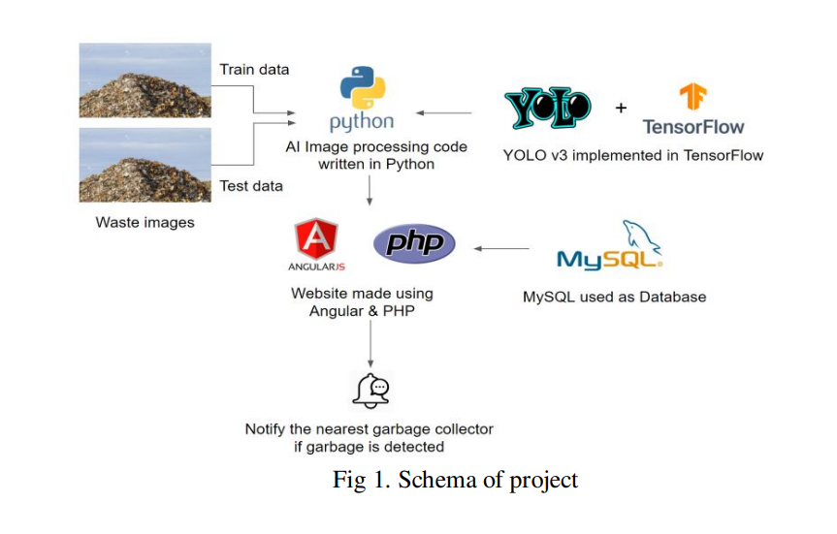
This diagram illustrates the high-level architecture and technology stack of a specific project.
Operational Flow & Components:
The diagram shows a flow that starts with raw data and ends in a practical, real-world action. Let's trace it through:
1.Waste Images (Inputs):
At the top left are two pictures showing a large pile of garbage or industrial waste.
These are labeled collectively as "Waste images".
The diagram shows that this dataset is split into two distinct parts:
Train data: A bracket indicates the top image is used for training the machine learning model
Test data: A separate bracket indicates the bottom image is used for testing and evaluating the model's performance.
Arrows show that both train and test data are fed into the next stage.

2.AI Image Processing (The Core Logic):
This component is centered around the Python programming language, represented by its logo
The text below states: "AI Image processing code written in Python". This block acts as the central hub for receiving data and applying algorithmic logic.
Crucially, a separate block on the right, labeled "YOLO v3 implemented in TensorFlow" (featuring both the YOLO and TensorFlow logos), has an arrow pointing towards the Python component. This indicates that the custom Python code is utilizing the powerful YOLO v3 (You Only Look Once, version 3) object detection model, which is built on the TensorFlow machine learning framework, to analyze the incoming waste images. Its goal would be to detect and locate garbage within the pictures.
3.The Website/Web Application Layer:
The processed information from the AI stage flows downwards via an arrow to a "Website made using Angular & PHP".
This indicates a web-based user interface and backend system.
AngularJS: Represented by its logo, this technology is a JavaScript framework used to build the front end (what the user sees) of the website.
PHP: Represented by its logo, this is a popular server-side scripting language used to create the back end, handling the business logic, API calls, and interaction with other components. This layer likely displays results, manages users, and handles logic for notifications.
4.Database Layer:
To the right of the web layer is a block with the MySQL logo and text: "MySQL used as Database".
An arrow points from the MySQL block to the PHP component. This indicates that the PHP backend communicates with a MySQL relational database to store and retrieve data, such as image information, detection results, collector details, and other essential records for the system's operation.

5.Final Outcome / Action:
An arrow points from the web application layer to the final stage at the bottom.
This is represented by a notification icon (a bell combined with a chat/speech bubble).
The associated text is: "Notify the nearest garbage collector if garbage is detected".
This is the functional endpoint of the entire process. If the image processing component successfully detects garbage, the system likely uses data stored in the database (location of detection, location of collectors) and the web logic to automatically trigger a notification sent directly to a real-world garbage collector to arrange for cleanup.
1.4OVERVIEW
The project helps in detecting and tracking waste in different areas.
It uses a mobile camera to capture images of garbage.
The system identifies the type of waste using AI technology.
It shows the waste location on a map and informs garbage collectors.
The system helps in cleaning waste quickly and keeping the environment clean.

S.NO | AUTHOR | PAPER TITLE | YEAR | CORE TECHNOLOGIES USED | LIMITATIONS
1. | Abhishek K. Lingaraju, et al. | IoT-Based Waste Segregation with Location Tracking and Air Quality Monitoring. | 2023 | ResNet/CNN for material type and Gas sensors for health tracking. | The system is complex and expensive due to the use of multiple sensors and deep learning models.
2. | Dr. Naga Malleshwar Rao, et al. | Geo tracking of waste and triggering alerts and mapping areas with high waste index. | 2022 | SSD MobileNet, CNN (AI),GPS for high-accuracy location mapping. | The AI model requires high computational power and may not work efficiently on low-end devices.
3. | Deep K. Pujara, P. Patel, S. Gajjar | Geo Tracking of Waste, Triggering Alerts and Mapping Areas with High Waste Index. | 2020 | Ultrasonic sensors, Arduino, and real-time mapping of waste hotspots. | System only monitors bin fill levels and cannot detect garbage dumped outside bins.
4. | Rohan David, et al. | GPS Based Garbage Tracking System. | 2019 | NodeMCU ESP8266 and Google Firebase for vehicle monitoring. | The system tracks garbage vehicles but does not detect actual waste locations.
2. LITERATURE SURVEY

3.

SYSTEM ANALYSIS
3.1 EXISTING SYSTEMS&DISADVANTAGES
The current waste management system mainly depends on fixed schedules and predefined collection routes, where garbage trucks follow the same paths regularly without checking whether waste has actually accumulated in specific areas. There is no real-time waste detection system to monitor garbage levels or identify newly dumped waste in unexpected locations such as street corners, empty plots, or isolated areas. As a result, overflowing bins and unplanned garbage spots often remain unattended until the next scheduled visit. The absence of proper tracking mechanisms, such as GPS monitoring or digital mapping of waste locations, makes it difficult for authorities to verify collections or identify high-waste zones. This leads to delayed cleaning responses, unpleasant odors, health risks, and public dissatisfaction. Additionally, the manual and schedule-based approach is time-consuming, wastes fuel and manpower, and increases operational costs, making the entire system inefficient and less responsive to real-world waste management challenges
Disadvantages:
- No Real-Time Monitoring: The system does not check garbage levels instantly. Trucks do not know whether bins are full or empty before visiting the area.
- Fixed Schedule Collection: Waste is collected only on specific days. If garbage accumulates before the scheduled day, it remains on the streets.
- Misses Newly Dumped Garbage: If people throw waste in empty plots or roadside corners, it is not noticed quickly. These areas stay dirty for many days.
- Delayed Cleaning Response: There is no quick action system. Overflowing bins must wait until the next collection cycle, causing inconvenience.
- Unhygienic Environment: Uncollected garbage creates bad smell and attracts flies, mosquitoes, and rodents, which may spread diseases.
- No GPS Tracking: Garbage trucks are not tracked digitally. Authorities cannot easily monitor their routes or performance.
- Lack of Accountability: It is difficult to confirm whether waste collection was properly completed in all assigned areas.
- Waste of Fuel and Time: Trucks visit every area even if there is little or no garbage. This wastes fuel, time, and manpower.
- High Operational Costs: Due to inefficient routing and repeated visits, the system increases fuel and maintenance costs.
- No Data Analysis: The system does not store proper digital records. Without data, authorities cannot identify high-waste areas or improve planning.
3.2 PROBLEMSTATEMENT
Improper waste disposal and the lack of real-time monitoring create serious problems in our surroundings. When garbage is thrown on roads, in empty plots, or near drains, it often remains there for many days because the traditional waste collection system works only on fixed schedules. Garbage trucks follow the same routes without checking where waste has newly accumulated. This leads to unattended garbage, bad smell, and an unhealthy environment. Uncollected waste causes air, land, and water pollution and attracts flies, mosquitoes, and rats that spread diseases. Since there is no proper tracking or instant alert system, cleaning is delayed and some areas are ignored. Therefore, a smart waste monitoring system is needed to detect waste in real time, identify its exact location, and inform authorities for quick and efficient cleanup, helping to maintain a clean and safe environment.
3.3 PROPOSED SYSTEM&ADVANTAGES
The proposed system is a smart waste management solution that uses AI and GPS technology to improve the efficiency of garbage collection. It includes AI-based waste classification to automatically identify different types of waste, which supports proper segregation and better recycling practices. The system also sends notifications after waste is collected, ensuring transparency and confirming that cleaning activities have been completed. By using GPS-based shortest path planning, garbage trucks are guided through the most efficient routes, reducing travel time, fuel consumption, and operational costs. In addition, the system enables real-time monitoring of waste accumulation, maintains digital records for analysis, and allows authorities to track vehicle movement, resulting in faster response, improved accountability, and a cleaner, healthier environment.

Advantages:
- Faster Cleanup: The system detects waste in real time and immediately informs authorities, allowing quick action. This reduces delays in garbage collection and keeps areas clean.
- No Missed Areas: With GPS tracking and digital mapping, all waste locations are recorded and monitored. This ensures that no area is ignored or left unattended.
- Real-Time Monitoring: The system continuously monitors waste levels and truck movements. Authorities can track collection status instantly and respond to issues quickly.
- Improved Communication: Automatic notifications and alerts improve communication between workers and administrators. This ensures better coordination and transparency in waste collection activities.
- Healthier Environment: Timely waste removal reduces pollution, bad smell, and the spread of diseases. Clean surroundings create a safer and healthier community.
- Data-Driven Planning: The system stores digital records of waste data, helping authorities analyze high-waste areas and plan efficient routes and schedules for better future management.

4.SYSTEM REQUIREMENT SPECIFICATIONS
4.1 FUNTIONAL REQUIREMENTS
- Image Capture / Upload of Waste the system allows users or field workers to capture and upload images of garbage using a mobile device. These images help in identifying the exact condition and location of waste for proper action.
- AI-Based Waste Detection (TensorFlow & YOLOv3) the uploaded images are analyzed using AI models like TensorFlow and YOLOv3 to automatically detect and classify waste. This helps in identifying the type and severity of garbage accumulation quickly and accurately.
- Map Visualization of Waste Areas all detected waste locations are displayed on a digital map. This visualization helps authorities easily identify high-waste zones and monitor multiple areas at once.
- Admin Notification to Garbage Collectors once waste is detected, the system sends notifications to the concerned garbage collectors. This ensures that the right team is informed immediately for faster cleanup.
- Waste Cleaning Status Update after the garbage is collected, the cleaning status is updated in the system. This provides confirmation of task completion and maintains proper digital records for monitoring and accountability.
4.2 NON-FUNCTIONALREQUIREMENTS
- High Detection Accuracy the system uses advanced AI models to accurately detect and classify waste from images. This reduces errors and ensures correct identification of garbage types.
- Real-Time Waste Tracking waste locations and collection activities are monitored in real time. Authorities can track garbage status instantly and respond quickly to issues.
- User-Friendly Interface the system is designed with a simple and easy-to-use interface. Users and administrators can upload images, check reports, and monitor status without technical difficulty.
- Reliable Data Storage & Retrieval all waste-related data, images, and reports are stored securely in a database. Information can be accessed anytime for tracking, analysis, and future planning.
- Scalability for Small Areas the system can be easily implemented in small areas such as villages, campuses, or local communities and can later be expanded to larger regions if needed.
- Mobile Camera Compatibility the system supports mobile camera integration, allowing users to capture and upload waste images directly from their smartphones for quick reporting and action.
4.3 SOFTWAREREQUIREMENTS
Operating system: Windows 11
Frontend: Angular JS
Backend: PHP
Database: MySQL
AI Engine: TensorFlow 2.0 & YOLO v3.
Libraries: Open CV-python
4.4 HARDWAREREQUIREMENTS
Processer: Intel Core i5
A mobile camera (for input) and a central server (for processing).
RAM: 4GB (min)

5.SYSTEM DESIGN
5.1 SYSTEM SPECIFICATION
The system specification for geo-tracking of waste includes both software and hardware components. It operates on Windows 11, with the frontend built using AngularJS and the backend developed in PHP, while MySQL is used for data storage. The AI engine integrates TensorFlow 2.0 and YOLOv3 along with OpenCV for waste detection and image processing. Development tools include Visual Studio Code, XAMPP, and Google Chrome. On the hardware side, the system requires a mobile camera for input and a central server for processing, with a minimum configuration of an Intel i5 processor or higher, 8GB RAM, and 256GB SSD storage to ensure efficient performance.
5.2 SYSTEM COMPONENTS
In this application there are several components as follows
Data Collection Module
Data Preprocessing & cleaning Module
Exploratory Data Analysis (EDA) Module
Feature Engineering
Module Modeling
Module Model Evaluation
Module Model Interpretation
Module Deployment Module
Monitoring and Feedback Module
Data Collection Module
To gather waste-related data from multiple sources such as mobile cameras, GPS sensors, and user inputs. It collects images of waste, location coordinates, and user reports, and aggregates them into a unified dataset for processing.
Data Preprocessing & Cleaning Module
To prepare raw image and location data for analysis by removing noise, handling missing values, and filtering irrelevant data. It also resizes images, normalizes inputs, and removes duplicate or incorrect location entries.

Exploratory Data Analysis (EDA)Module
To analyze waste patterns and distribution across different locations. It visualizes data using maps, charts, and graphs to identify high waste density areas and trends over time.
Feature Engineering Module
To create meaningful features such as waste type, location frequency, time of reporting, and area-wise waste density. It helps improve the performance of prediction and detection models.
Modeling Module
To build AI models that detect and classify waste from images using TensorFlow 2.0 and YOLOv3. It involves training, validation, and testing of models for accurate waste detection.
Model Evaluation Module
To evaluate the performance of the waste detection model using metrics such as accuracy and precision. It also checks detection quality and compares results across different models.
Model Interpretation Module
To understand how the model identifies waste and which features influence detection. It helps developers and stakeholders trust the system by explaining predictions.
Deployment Module
To deploy the system for real-time usage by integrating the model into an application using APIs and servers. It enables users to upload images and receive detection results instantly through a web or mobile interface.
Monitoring & Feedback Module
To continuously monitor system performance, track detection accuracy, and collect user feedback. It helps in identifying issues, improving the model, and updating the system for better efficiency over time.

5.3 DATA FLOW DIAGRAM
A Data Flow Diagram (DFD) is a graphical tool used in system design to represent how data flows through a system. It illustrates the movement of data from input to processing and finally to output. DFDs help in understanding how information is handled within a system by showing where data comes from, how it is processed, and where it is stored or sent.
A DFD consists of four main components: processes, data flows, data stores, and external entities. A process represents an activity that transforms input data into output. Data flow shows the movement of data between different parts of the system using arrows. A data store represents a place where data is stored, such as a database or file. External entities are outside sources or destinations of data, like users or other systems.
DFDs are created in different levels to show increasing detail. The Level 0 DFD, also known as the context diagram, represents the entire system as a single process and shows its interaction with external entities. Level 1 DFD breaks the system into smaller processes, providing more detail. Level 2 and further levels give an even more detailed view of the system’s internal workings.
Overall, a Data Flow Diagram is useful for analyzing, designing, and documenting systems. It improves communication among developers and stakeholders and helps in identifying errors or inefficiencies in the system at an early stage.

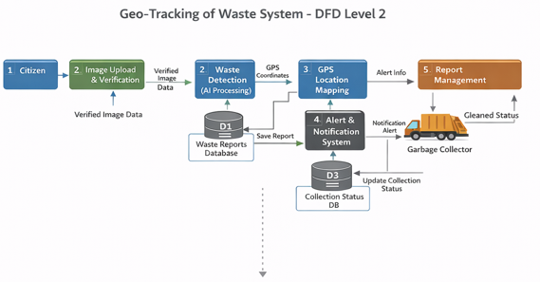

5.4 UML DIAGRAMS
5.4.1 CLASS DIAGRAM
The class diagram represents a waste detection system that uses images to identify garbage and manage reports. In this system, the User logs in, uploads images of waste, and checks the status of their submissions. These images are stored in the Waste Image class along with location details such as latitude and longitude. The uploaded images are then processed by the YOLO Detector, which acts as the intelligent component to detect garbage using an AI model. Once the waste is detected, the results are stored in the Database for future reference and report generation. The Notification Service sends alerts to the concerned authorities or collectors based on the detection results. Meanwhile, the Admin manages users and monitors reports to ensure the system runs smoothly. Overall, the system automates the process of identifying, tracking, and responding to garbage issues efficiently.

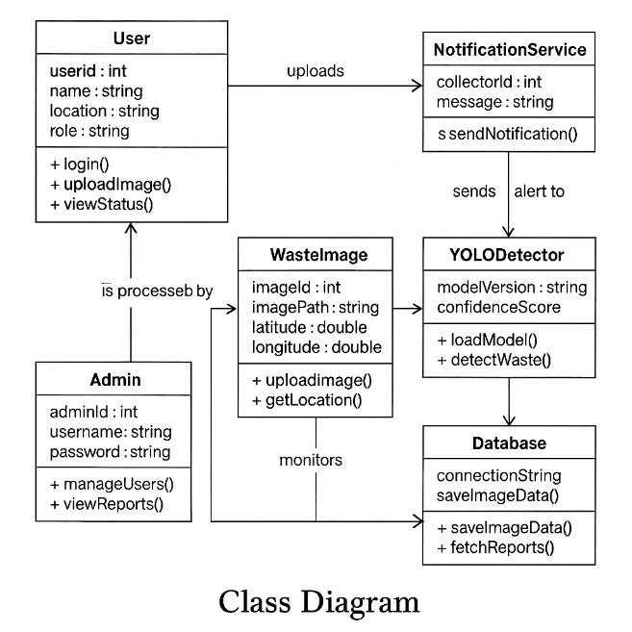

5.4.2 USECASE DIAGRAM
This use case diagram represents the functionality of a Waste Detection System and shows how different users interact with the system.The main actor is the User, who first registers or logs into the system and then uploads an image of waste. Once the image is uploaded, the system automatically includes the Detect Waste (AI Processing) function, where the AI model analyzes the image to identify garbage. If waste is detected, the system extends to the Send Notification use case, which sends alerts to the concerned authorities or garbage collectors.The Admin is another actor who can also interact with the system, mainly to monitor activities and manage users through the Manage Users function. After receiving the notification, the Garbage Collector takes action and updates the cleanup status using the Update Cleanup Status use case.Overall, this diagram explains how users, admin, and garbage collectors interact with the system, from uploading waste images to detecting garbag e and completing the cleanup process.

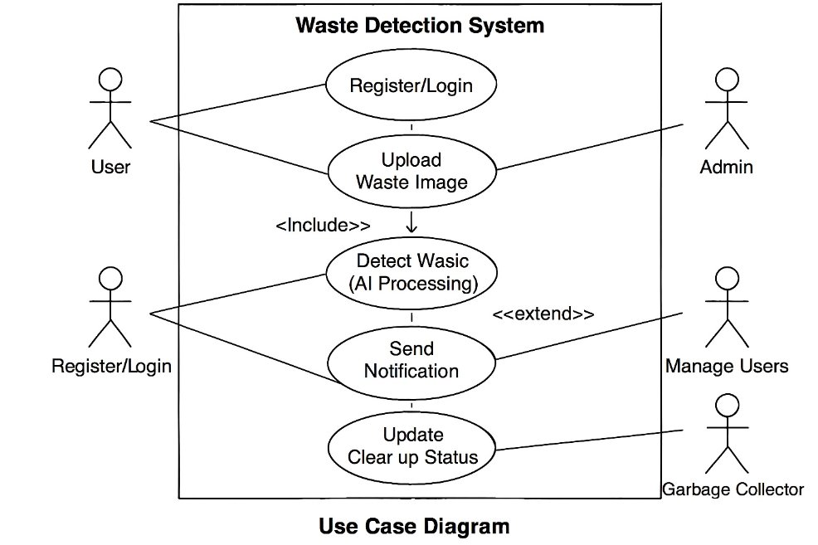

5.4.3 ACTIVITY DIAGRAM
This activity diagram shows the step-by-step working of a waste detection system. The process begins when a user uploads an image of garbage. After the image is uploaded, the system captures the location details such as latitude and longitude. Then, the system checks whether waste is detected in the image. If waste is detected, a notification is sent to the concerned collector or authority for cleanup action. If no waste is detected, the data is simply stored in the database for record purposes. Once the notification is sent, the collector updates the cleanup status after taking action. Finally, the process ends. This diagram clearly explains how the system flows from image upload to waste detection and cleanup management.
ROP
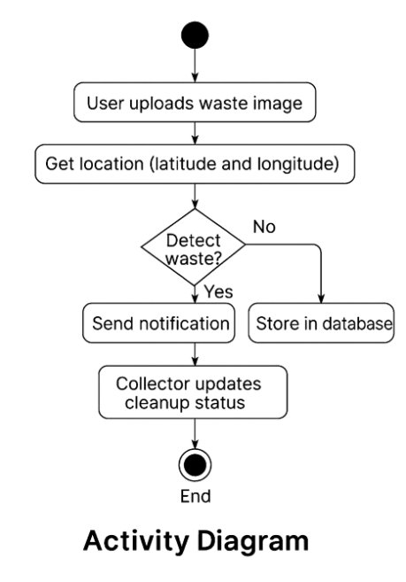

5.4.4 COMPONENT DIAGRAM
This component diagram represents the architecture of an AI-based waste detection system and shows how different system components interact with each other.The process begins with the Angular Web Application (Frontend), where the user uploads a waste image. This frontend sends an HTTP request to the PHP Backend API, which acts as the main controller of the system. The backend forwards the image processing request to the Python AI Module, which handles the core logic of analyzing the image.The Python AI Module interacts with the YOLO Detection Model to detect whether waste is present in the image. Once the detection is completed, the results are sent back to the Python module. These results are then stored in the MySQL Database for future reference and reporting.If waste is detected, the system triggers the Notification Service (SMS/Email), which sends alerts to the concerned authorities or garbage collectors. At the same time, the notification is also reflected in the Garbage Collector Interface (Dashboard), where collectors can view alerts and take necessary action.Overall, this diagram explains how the frontend, backend, AI module, detection model, database, and notification system work together to create an efficient waste detection and alert system.

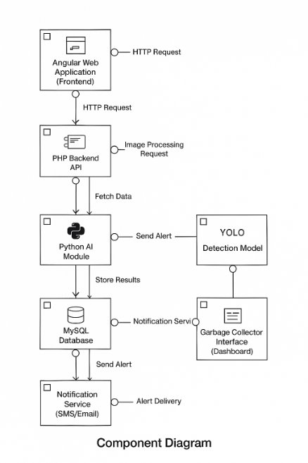

5.4.5 SEQUENCE DIAGRAM
This sequence diagram represents how the AI-Based Waste Detection System using YOLO works step by step by showing the interaction between different components.The process starts when the user uploads a waste image through the AngularJS application. The application then sends the image along with location data to the PHP backend API. The backend forwards the image to the YOLO detection model, which processes the image using the Python AI module to detect whether waste is present or not.After processing, the system checks the result. If waste is detected, an alert is sent through the notification service, which notifies the garbage collector for cleanup. At the same time, the detection result and image data are stored in the MySQL database. If no waste is detected, the system simply returns the status to the application without sending any notification, but the data may still be stored for record purposes.Finally, the result (whether waste is detected or not) is sent back to the user through the application. This diagram clearly shows the flow of communication between the frontend, backend, AI model, database, and notification system in a time-based sequence.

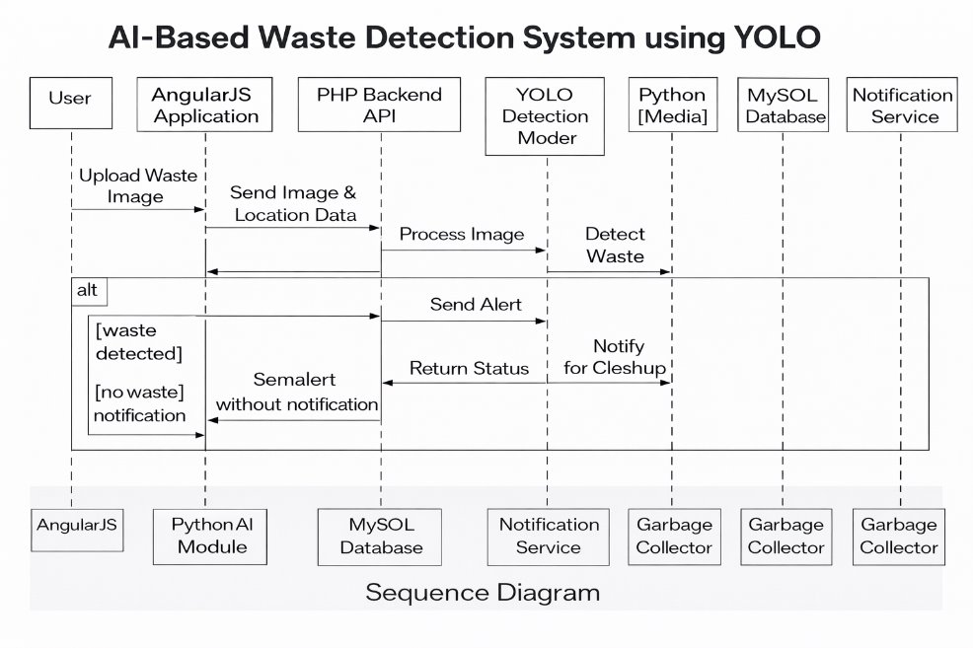
6.IMPLEMENTATION
6.1 SAMPLE CODE
import { Component, OnInit } from '@angular/core';
import { CommonModule } from '@angular/common';
import { RouterLink } from '@angular/router';
declare var lucide: any;
@Component({
selector: 'app-landing',
standalone: true,
imports: [CommonModule, RouterLink],
template: `
<header>
<a routerLink="/" class="logo">
<img src="logo.png" alt="OrbitBin Logo" style="height: 40px; margin-right: 10px;">
<div class="logo-text">Orbit<span>Bin</span></div>
</a>
<nav>
<ul>
<li><a routerLink="/">Home</a></li>
<li><a href="#features">Smart Solutions</a></li>
<li><a href="#">Sustainability</a></li>
<li><a routerLink="/login" class="btn-login">Login Portal</a></li>
</ul>
</nav>
</header>
<section class="hero">
<div class="hero-content">
<span class="hero-label">Reinventing Urban Hygiene</span>
<h1>Smarter Cities Start With Smarter Waste.</h1>
<p>OrbitBin empowers communities with real-time geo-tracking and AI-driven insights to create cleaner,
healthier environments for everyone.</p>
<a routerLink="/login" class="btn-primary">
Start Tracking
<i data-lucide="arrow-right"></i>
</a>
</div>
</section>
<section class="features" id="features">
<div class="section-header">
<span>Our Core Technology</span>
<h2>Intelligence Meets Infrastructure</h2>
</div>
<div class="feature-grid">
<div class="feature-card">
<div class="icon-box">
<i data-lucide="map-pin"></i>
</div>
<h3>Precision Geo-Tracking</h3>
<p>Pinpoint waste collection needs in real-time using advanced GPS tracking.</p>
</div>
<div class="feature-card">
<div class="icon-box">
<i data-lucide="cpu"></i>
</div>
<h3>AI Waste Classification</h3>
<p>Machine learning models analyze waste composition instantly for better recycling.</p>
</div>
<div class="feature-card">
<div class="icon-box">
<i data-lucide="bar-chart-3"></i>
</div>
<h3>Operational Analytics</h3>
<p>Data dashboards help city planners reduce costs and improve efficiency.</p>
</div>
</div>
</section>
<footer>
<div class="footer-content">
<div class="footer-brand">
<h2>OrbitBin.</h2>
<p>Pioneering the next generation of urban sanitation technology.</p>
</div>
<div class="footer-links">
<h4>Platform</h4>
<ul>
<li><a href="#">Citizen App</a></li>
<li><a href="#">Staff Portal</a></li>
<li><a href="#">City API</a></li>
</ul>
</div>
<div class="footer-links">
<h4>Company</h4>
<ul>
<li><a href="#">About Us</a></li>
<li><a href="#">Careers</a></li>
<li><a href="#">Contact</a></li>
</ul>
</div>
</div>
<div class="footer-bottom">
&copy; 2026 OrbitBin Systems Inc. All rights reserved.
</div>
</footer>
styles: [`
:host {
--brand-blue: #0f172a;
--brand-gold: #fbbf24;
--brand-green: #10b981;
--text-main: #334155;
--text-light: #64748b;
--bg-light: #f8fafc;
--white: #ffffff;
--glass: rgba(255, 255, 255, 0.95);
display: block;
}
/* NAVIGATION */
header {
position: fixed;
top: 0;
width: 100%;
padding: 1rem 5%;
z-index: 1000;
background: var(--glass);
backdrop-filter: blur(10px);
border-bottom: 1px solid rgba(0, 0, 0, 0.05);
display: flex;
justify-content: space-between;
align-items: center;
}
logo {
display: flex;
align-items: center;
gap: 12px;
text-decoration: none;
}
logo img {
height: 40px;
}
logo-text {
font-size: 1.5rem;
font-weight: 800;
color: var(--brand-blue);
}
logo-text span {
color: var(--brand-green);
}
nav ul {
display: flex;
list-style: none;
gap: 2.5rem;
align-items: center;
margin: 0;
padding: 0;
}
nav a {
text-decoration: none;
color: var(--text-main);
font-weight: 500;
position: relative;
}
nav a:after {
content: '';
position: absolute;
width: 0;
height: 2px;
bottom: -4px
left: 0;
background-color: var(--brand-green);
transition: width 0.3s;
}
nav a:hover::after {
width: 100%;
}
btn-login {
padding: 0.6rem 1.8rem;
background: var(--brand-blue);
color: white !important;
border-radius: 50px;
font-weight: 600;
}
btn-login::after {
display: none;
}
btn-login:hover {
background: var(--brand-green);
/* HERO */
hero {
position: relative;
min-height: 100vh;
display: flex;
align-items: center;
padding: 0 5%;
background: linear-gradient(135deg, #f0fdf4 0%, #fefce8 100%);
}
hero:before {
content: '';
position: absolute;
top: 0;
right: 0;
width: 50%;
height: 100%;
background:
url('https://images.unsplash.com/photo-1542601906990-24d4c16419d9?q=80&w=1920&auto=format&fit=crop') no-repeat center center;
background-size: cover;
clip-path: polygon(20% 0, 100% 0, 100% 100%, 0% 100%);
opacity: 0.9;
}
hero-content {
position: relative;
max-width: 900px;
z-index: 10;
text-align: center;
margin: 0 auto;
}

.hero-label {
display: inline-block;
background: rgba(16, 185, 129, 0.1);
color: var(--brand-green);
padding: 6px 12px;
border-radius: 20px;
font-size: 0.85rem;
font-weight: 700;
margin-bottom: 20px;
text-transform: uppercase;
}
hero h1 {
font-family: 'Playfair Display', serif;
font-size: 4rem;
line-height: 1.1;
color: var(--brand-blue);
margin-bottom: 1.5rem;
}
hero p {
font-size: 1.15rem;
color: var(--text-light);
margin-bottom: 2.5rem;
}
btn-primary {
background: var(--brand-green);
color: white;
padding: 1rem 2.5rem;
border-radius: 50px;
text-decoration: none;
font-weight: 600
display: inline-flex;
align-items: center;
gap: 10px;
}
btn-primary:hover {
background: #0ea371;
color: white;
/* FEATURES */
features {
padding: 8rem 5%;
background: white;
text-align: center;
}
section-header span {
color: var(--brand-green);
font-weight: 700;
text-transform: uppercase;
font-size: 0.9rem;
}

.section-header h2 {
font-size: 2.5rem;
color: var(--brand-blue);
margin: 10px 0 50px;
font-family: 'Playfair Display', serif;
}

feature-grid {
display: grid;
grid-template-columns: repeat(auto-fit, minmax(280px, 1fr));
gap: 30px;
}

.feature-card {
background: var(--bg-light);
padding: 40px;
border-radius: 20px;
transition: 0.3s;
text-align: left;
}

.feature-card:hover {
background: white;
transform: translateY(-8px);
box-shadow: 0 20px 40px rgba(0, 0, 0, 0.05);
}

.icon-box {
width: 60px;
height: 60px;
background: white;
border-radius: 15px;
display: flex;
align-items: center;
justify-content: center;
margin-bottom: 25px;
color: var(--brand-green);
}
feature-card h3 {
font-size: 1.3rem;
margin-bottom: 15px;
color: var(--brand-blue);
}
feature-card p {
color: var(--text-light);
}
/* FOOTER */
footer {
background: var(--brand-blue);
color: #94a3b8;
padding: 5rem 5% 2rem;
}
footer-content {
display: grid;
grid-template-columns: 2fr 1fr 1fr;
gap: 50px;
border-bottom: 1px solid rgba(255, 255, 255, 0.1);
padding-bottom: 4rem;
margin-bottom: 2rem;
}
footer-brand h2,
footer-links h4 {
color: white;
margin-bottom: 1rem;
}
footer-links ul {
list-style: none;
padding: 0;
}
footer-links li {
margin-bottom: 10px;
}
footer-links a {
color: #94a3b8;
text-decoration: none;
}
footer-links a:hover {
color: var(--brand-gold);
}
footer-bottom {
text-align: center;
font-size: 0.9rem;
}
@media (max-width: 968px) {
nav ul {
display: none;
}
hero h1 {
font-size: 2.8rem;
}
hero: before {
display: none;
}
footer-content {
grid-template-columns: 1fr;
text-align: center;
}
}
`]
})
export class LandingComponent implements OnInit {

ngOnInit() {
// Re-initialize lucide icons since this is an SPA navigation
setTimeout(() => {
if (typeof lucide !== 'undefined') {
lucide.createIcons();
}
}, 100);
}

7.SYSTEM TESTING
System testing is a level of software testing in which the complete and fully integrated system is tested as a whole. The main purpose of system testing is to verify that the entire application meets the specified requirements and works correctly in a real-world environment. It ensures that all components of the system function together without errors.
This testing is performed after integration testing and before acceptance testing. At this stage, the system is treated as a complete product, and testers focus on validating both functional and non-functional requirements such as performance, security, usability, and reliability.
System testing is usually carried out in an environment that closely resembles the actual production environment. It involves testing end-to-end workflows, meaning the tester checks the entire process from start to finish, just like a real user would interact with the system.
For example, in a geo tracking of waste management system, system testing would include checking whether users can register and log in, whether waste bin locations are correctly displayed on the map, whether alerts are generated when bins are full, and whether the admin can monitor and manage the system effectively.
In conclusion, system testing plays a crucial role in ensuring that the complete application works smoothly, meets user expectations, and is ready for deployment without major defects.

7.1 TYPES OF TESTING
Functional Testing
Functional testing is a type of software testing that verifies whether each feature of the system works according to the specified requirements. It checks the correctness of inputs, processing, and outputs. In a Geo-Tracking Waste Management System, it ensures functions like GPS tracking, bin status detection, and alerts operate properly.
Integration Testing:
Integration testing ensures that different modules of the system interact correctly with each other. It checks the data flow between components like sensors, GPS modules, backend server, and dashboard. It helps identify issues in communication between modules. In this system, it ensures data from sensors and GPS is correctly displayed. It is performed after unit testing.
3. System Testing:
System testing evaluates the complete system as a whole to ensure it meets all requirements. It checks the end-to-end workflow from waste detection to route optimization and final display. This testing validates both functional and non-functional aspects. It ensures the system behaves correctly in real scenarios. It is done before deployment.
4. Performance Testing:
Performance testing checks how the system performs under different workloads. It evaluates speed, response time, scalability, and stability. In this system, it ensures smooth operation when many vehicles send GPS data simultaneously. It includes load and stress testing. It helps improve system efficiency.
5. Security Testing:
Security testing ensures that the system is protected against unauthorized access and threats. It checks authentication, authorization, and data encryption. In this system, it protects sensitive data like vehicle location and user details. It prevents hacking and data breaches. It ensures system safety and reliability.
6. Usability Testing:
Usability testing evaluates how easy and user-friendly the system is to use. It focuses on interface design, navigation, and user experience. In this system, it ensures users can easily monitor waste collection and view maps. It improves user satisfaction. A simple and clear interface is the goal.
7. Regression Testing:
Regression testing ensures that new changes or updates do not affect existing functionalities. It verifies that previously working features still function correctly. In this system, adding new features like alerts should not break GPS tracking. It helps maintain system stability. It is performed after every update.
8. Real-Time Testing:
Real-time testing checks the system’s ability to process and update live data instantly. It ensures GPS locations and alerts are updated without delay. In this system, vehicle movement should reflect on the dashboard in real-time. It is critical for tracking applications. It ensures accuracy and timeliness.
9. Field Testing:
Field testing is performed in real-world conditions to check system performance. It tests GPS accuracy, sensor functionality, and network reliability. In this system, it involves testing on actual waste collection vehicles. It helps identify practical issues. It ensures the system works effectively in real environments.

7.2 TEST CASES
Test Case 1: User Login
Test Cases Status | Priority (H, L): High
Test Objective | Verify login functionality
Test Description | Only registered users can log in
Requirements Verified | Valid email & password
Test Environment | Android/Web
Test Setup | Navigate to Login page → Enter registered email & password → Click Login
Inputs | Expected Result | Actual Result
Submit with invalid details | Error message displayed | Correct
Submit with valid details | Redirect to dashboard | Success
Pass: Yes | Conditional Pass: No | Fail: No

TEST CASE 2: Waste Bin Location Detection (GPS)
Test Cases Status | Priority (H, L): High
Test Objective | Verify GPS-based location tracking
Test Description | System should detect real-time bin location
Requirements Verified | GPS enabled
Test Environment | Android device with GPS
Test Setup | Enable GPS → Open app → Allow location permission
Inputs | Expected Result | Actual Result
GPS OFF | Error message | Correct
GPS ON | Accurate location displayed | Success
Pass: Yes | Conditional Pass: No | |Fail: No

Test Case 3: Dashboard Visualization
Test Cases Status | Priority (H, L): Medium
Test Objective | Verify dashboard display
Test Description | Show bin data, status, and analytics
Requirements Verified | Data integration
Test Environment | Web
Test Setup | Login → Open dashboard
Inputs | Expected Result | Actual Result
Load dashboard | Data displayed | Correct
Multiple bins | Graph updates | Correct
Pass: Yes | Conditional Pass: No | Fail: No

Test case 4: Alerts & Notifications
Test Cases Status | Priority (H, L): Medium
Test Objective | Verify alert notification system
Test Description | System alerts when bin is full
Requirements Verified | Notification system
Test Environment | Android/Web
Test Setup | Simulate bin full condition → Enable notifications
Inputs | Expected Result | Actual Result
Bin full Alert sent Success | Alert sent | Success
Bin normal | No alert | Correct
Pass: Yes | Conditional Pass: No | Fail: No

Test Case 5: Map Integration
Test Cases Status | Priority (H, L): High
Test Objective | Verify map integration
Test Description | Display bins on map with location
Requirements Verified | Map API
Test Environment | Web/Android
Test Setup | Open map view → Load bin data
Inputs | Expected Result | Actual Result
Load map | Map displayed | Success
Bin locations | Markers shown | Correct
Pass: Yes | Conditional Pass: No | Fail: No

7.3 DISCUSSION OF RESULTS
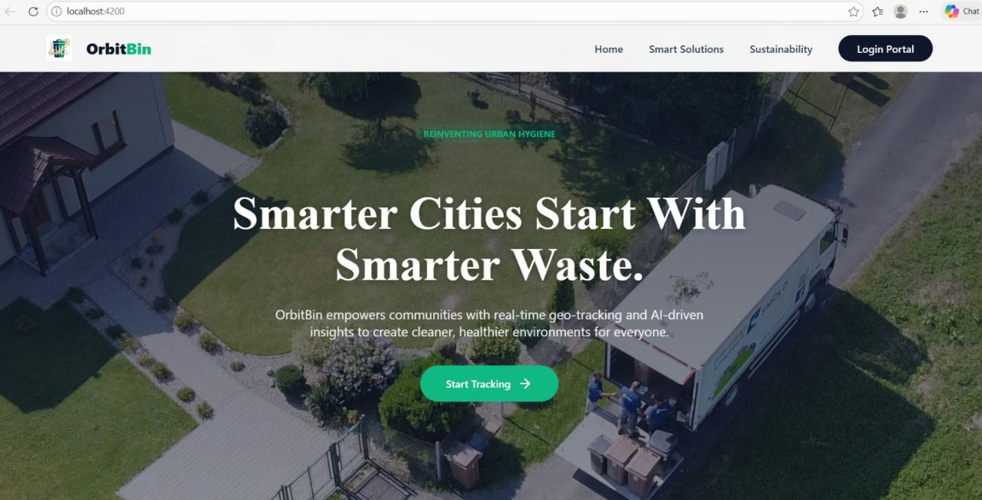
Figure 7.3.1 Home Page of OrbitBin System
    - This image shows the OrbitBin home page with a focus on smart waste management.
    - It highlights features like real-time tracking and AI-based insights for cleaner cities.
    - A “Start Tracking” button allows users to begin using the system.


Figure 7.3.2: User Sign-Up Page
- This image shows the OrbitBin login page with options for Citizen and Staff.
- It includes username and password fields and a login button.
- Users can also register or return to the home page.

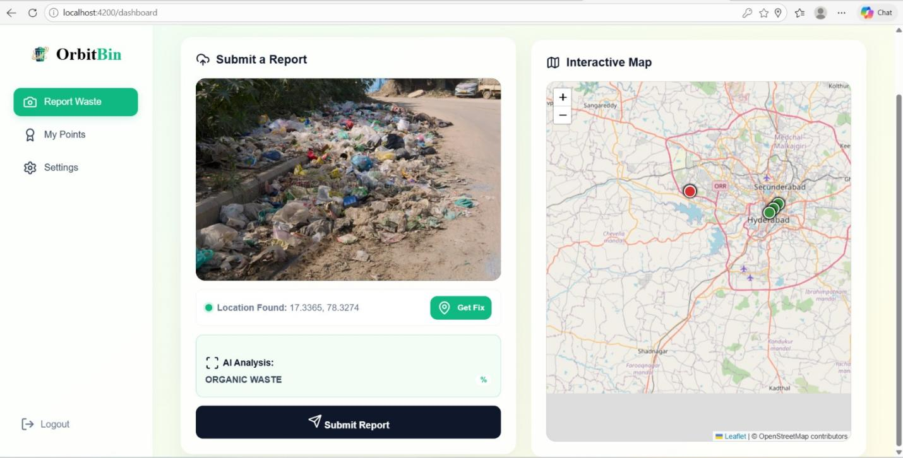
Figure 7.3.3:Waste Reporting Dashboard Page
- This image shows the OrbitBin dashboard for reporting waste.
- It includes an uploaded waste image, detected location, and AI-based waste analysis.
- An interactive map displays the report location.



Figure 7.3.4: Submission success page
- The image shows a successful submission popup with a confirmation message.
- It highlights earned points and notifies that a collector has been assigned.
- Users can choose to report more waste or view their points.

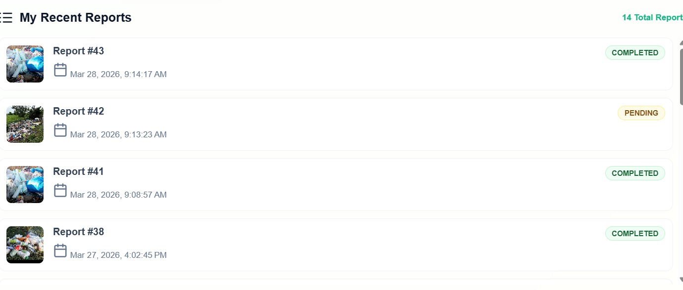
Figure 7.3.5:Recent reports page
- The image shows a list of recent reports submitted by a user.
- Each entry includes a report number, date, time, and status such as completed
or pending.
- It provides a quick overview of report history and progress.

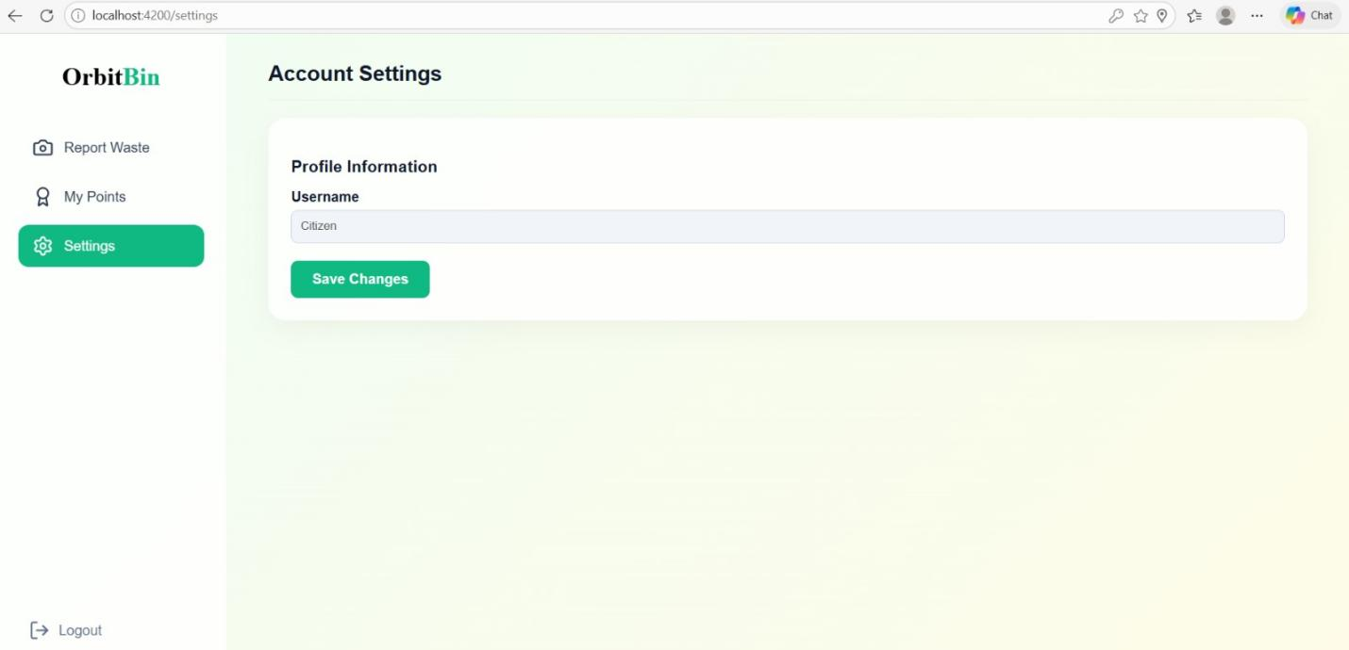
Figure 7.3.6: OrbitBin user account settings page
- This image shows the "Account Settings" page of the OrbitBin web application.
- It features a left-hand navigation sidebar and a main panel where users can view and update
- their profile username.

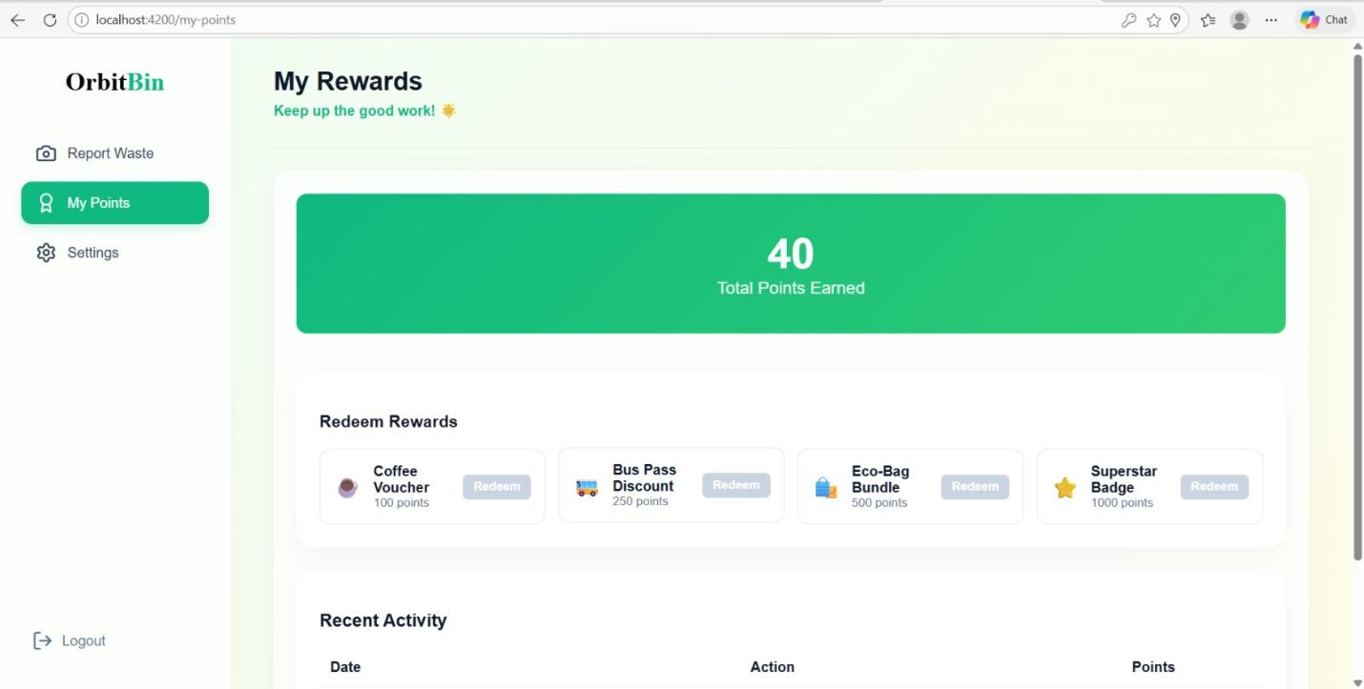
Figure 7.3.7: OrbitBin rewards and points redemption dashboard
- This interface displays the "My Rewards" dashboard within the OrbitBin platform
highlighting the user's gamification progress.
- A prominent green banner shows "40 Total Points Earned," followed by a section to
redeem points for rewards like vouchers and badges.
- A "Recent Activity" log is also included at the bottom to track point history.

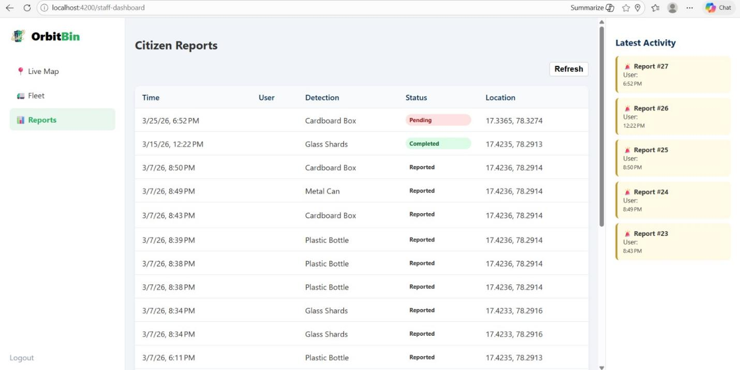
Figure 7.3.8: OrbitBin staff dashboard for monitoring and managing citizen waste report
- This screenshot displays the "Citizen Reports" administrative dashboard for the OrbitBin platform.
- The interface features a central table tracking waste detection data, including timestamps, waste types (e.g., plastic bottles, glass shards), processing status, and precise GPS coordinates.
- A "Latest Activity" sidebar on the right provides real-time updates on the most recent incident reports.

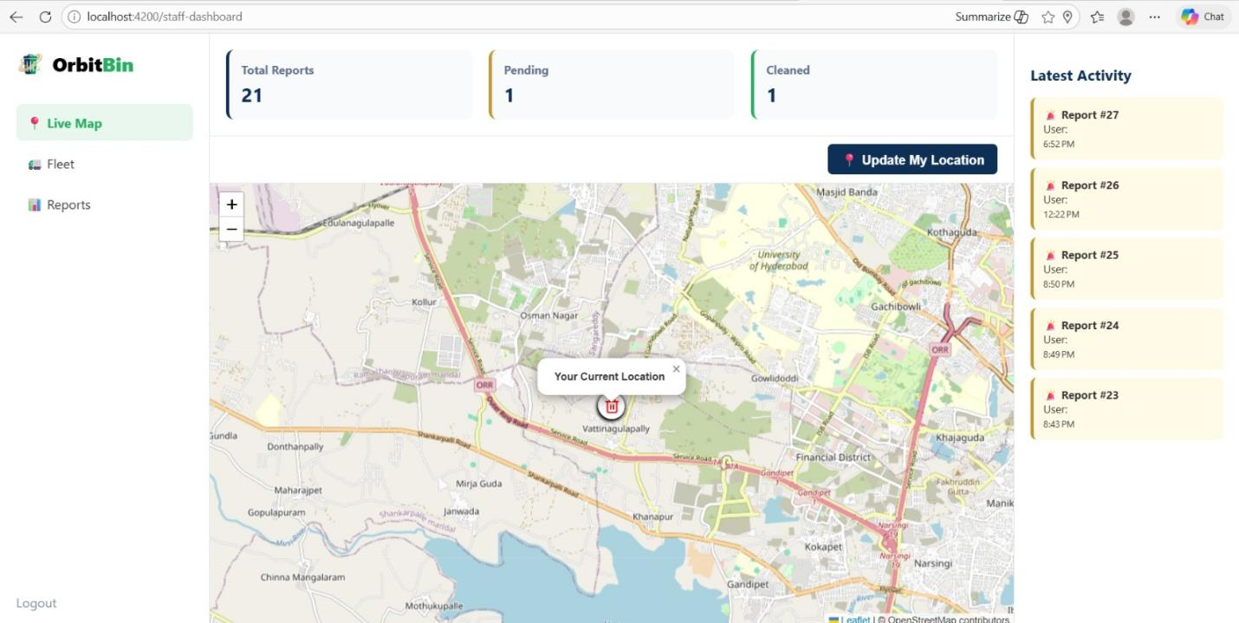
Figure 7.3.9: OrbitBin live map interface for geospatial waste tracking and analytics
- This image features the "Live Map" view of the OrbitBin staff dashboard, centered on a
real-time geographic tracking interface.
- At the top, statistical cards summarize "Total Reports," "Pending," and "Cleaned" tasks, while
- the interactive map highlights the user's current location with a bin icon.
- The "Latest Activity" sidebar persists on the right, providing context for recent reports
alongside the spatial data.

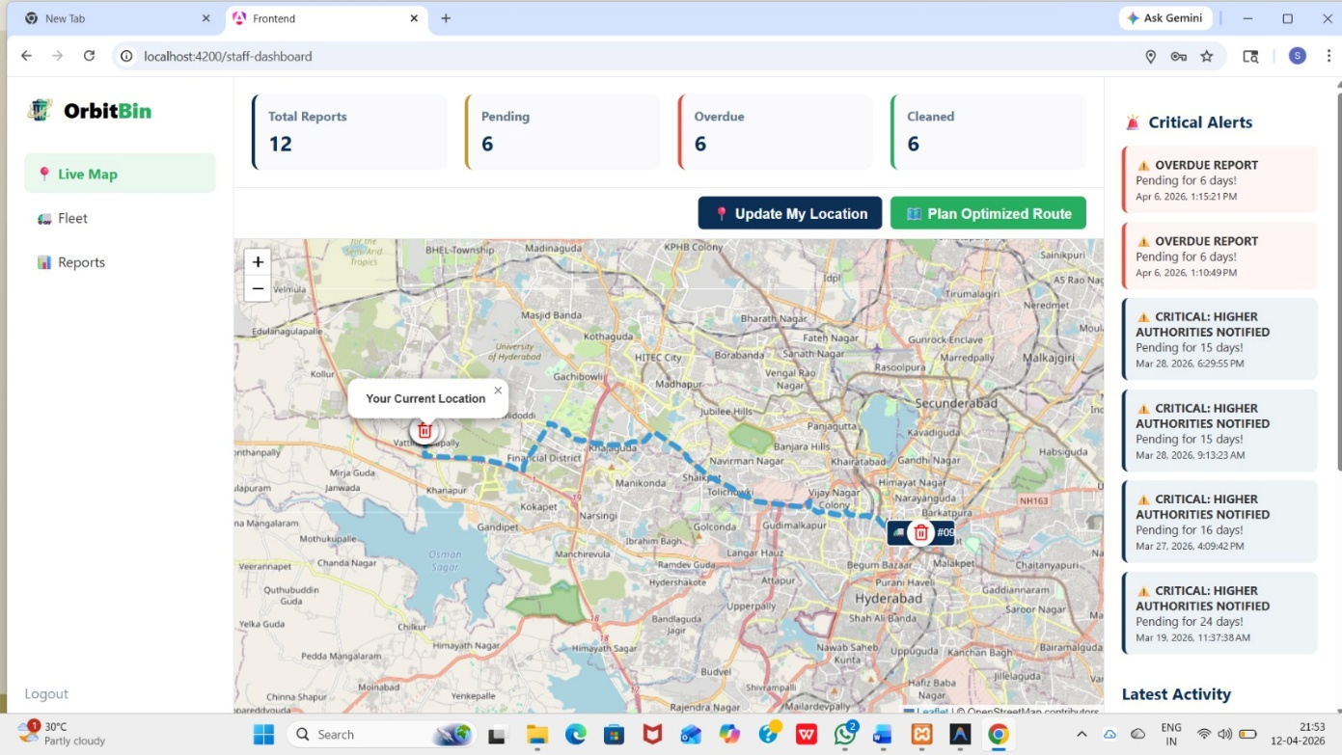
Figure 7.3.10 Route Optimization Page
- This image shows the OrbitBin route optimization page for staff.
- It displays a live map with optimized routes for waste collection.
- The system helps track locations and manage reports efficiently.

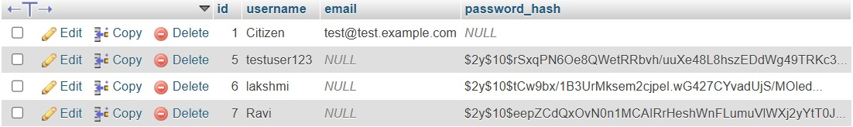
Figure 7.3.10: Backend database view of the user credentials table
- This image displays a phpMyAdmin database table view containing user account information.
- The table includes columns for unique IDs, usernames, email addresses, and encrypted
password hashes, showing several registered test accounts.
- This backend view confirms the successful storage and management of user data within
the system's database.

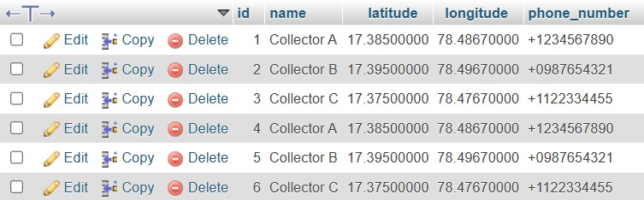
Figure 7.3.11: Database table displaying collector details and geographic coordinates
- This image shows a phpMyAdmin database table containing records for waste collectors.
- The table includes columns for unique IDs, collector names, precise latitude and
longitude coordinates for location tracking, and contact phone numbers.
- This structured data allows the system to identify and dispatch the nearest available collector
to a reported waste site.

8.CONCLUSION &FUTUREENHANCEMENTS
8.1 CONCLUSION
The results indicate that the Geo-Tracking Waste Management System provides improved efficiency and effectiveness in waste collection operations compared to traditional methods. The system demonstrates better performance in terms of real-time monitoring, route optimization, and timely waste collection.
Efficiency (around 80–90%) represents the overall improvement in waste collection operations, including reduced delays and better resource utilization. The system minimizes unnecessary trips and ensures that waste is collected only when bins are full, reducing operational costs.
Accuracy (high GPS precision) measures how correctly the system tracks the location of waste collection vehicles. The system shows high accuracy in real-time tracking, ensuring reliable monitoring and better decision-making.
Response Time (low latency) indicates how quickly the system reacts to events such as bin overflow alerts. The system provides fast notifications, enabling timely action and preventing overflow situations.
Reliability (consistent performance) reflects the system’s ability to function continuously without failure. The system performs reliably under different conditions, though minor issues like network delays or GPS signal loss may occur.
Scalability (moderate to high) shows that the system can handle increasing numbers of bins, vehicles, and users. However, performance may slightly decrease with very large-scale deployments without optimization.
The Geo-Tracking Waste Management System performs better than conventional waste management approaches by improving efficiency, accuracy, and responsiveness. However, there is still scope for improvement in handling network issues, enhancing real-time synchronization, and optimizing large-scale performance.

8.2 FUTURE ENHANCEMENTS
The Geo-Tracking Waste Management System can be further enhanced by incorporating advanced technologies such as Artificial Intelligence and Machine Learning for dynamic route optimization and predictive waste analysis, enabling better planning and reduced operational costs. Future developments may include fully functional mobile applications for citizens, drivers, and administrators to support real-time tracking, complaint registration, and instant notifications. Integration of IoT-enabled smart bins with sensors for fill level, temperature, and hazardous waste detection can improve monitoring accuracy and safety. The system can also be connected with real-time traffic data and GIS mapping for efficient navigation and reduced delays. Cloud-based deployment will allow large-scale data handling, better storage, and easy scalability for smart city implementations. Additionally, advanced dashboards with data visualization, heatmaps, and performance analytics can support decision-making, while stronger cybersecurity measures and integration with government platforms can ensure data safety, transparency, and improved urban waste management services.

9.REFERENCES
[1] Abhishek K. Lingaraju, et al. (2023).IoT-Based Waste Segregation with Location Tracking and Air Quality Monitoring.
[2] Dr. Naga Malleshwar Rao, et al.(2022).Geo tracking of waste and triggering alerts and mapping areas with high waste index.
[3] Deep K. Pujara, P. Patel, S. Gajjar .(2020).Geo Tracking of Waste, Triggering Alerts and Mapping Areas with High Waste Index.
[4] Rohan David, et al .(2019).GPS Based Garbage Tracking System.
[5] Nair, P., & Menon, R. (2023). GIS-Based Waste Collection System for Urban Sustainability. International Journal of Geographical Information Science, 37(1), 150–168.
[6] Singh, R., & Verma, K. (2023). Data Analytics for Optimization of Waste Collection Routes. International Journal of Data Science and Analytics, 6(1), 33–47.
[7] Thomas, J., & George, P. (2022). Mobile-Based Waste Tracking Application for Municipal Services. Journal of Mobile Computing and Applications, 14(2), 60–72.
[8] Das, S., & Roy, A. (2022). Implementation of Smart Waste Management System Using Machine Learning and GPS. Journal of Big Data Analytics in Transportation, 4(2), 89–101.
[9] Choudhary, V., & Tiwari, S. (2021). Smart Bin Monitoring and Waste Collection System Using Sensors and IoT. International Journal of Engineering Research & Technology, 10(7), 223–229.
[10] Yadav, K., & Mishra, D. (2020). Smart City Waste Management Using Cloud and IoT Technologies. International Journal of Cloud Computing, 9(3), 201–215.

